Staff use case

Logout

Reference to user

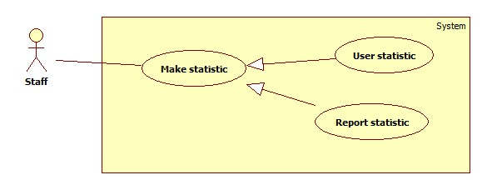

|  |  |  |  |
| --- | --- | --- | --- |
| **USE CASE – SU001** | | | |
| **Use Case No.** | SU001 | **Use Case Version** | 1.0 |
| **Use Case Name** | Make statistic | | |
| **Author** | Ho Dac Nghia | | |
| **Date** | 15/01/2014 | **Priority** | Normal |
| **Actor:** Staff  **Summary:**  Staff use this case to make statistic  **Goal:**   * Allow staff get information about user and report statistic   **Triggers:**   * Click menu item “Thống kê” * Select “Thống kê người dùng” or “Thống kê phản hồi” * Select the time in “Từ ngày”, “Đến ngày” * Press “Xác nhận”   **Preconditions:**   * Staff must login system.   **Post Conditions:**   * **Success:** Display statistic result * **Fail:** No statistics info displayed   **Main Success Scenario:**   |  |  |  | | --- | --- | --- | | Step | Actor Action | System Response | | 1 | Click menu item“Thống kê” | System redirect to statistic page | | 2 | Staff select “Thống kê người dùng”, input time in “Từ ngày”, “Đến ngày” and press “Xác nhận” button  [Alternative 1] | System display statistic information  [Exception 1, 2 ] |   **Alternative Scenario:**   |  |  |  | | --- | --- | --- | | No | Actor Action | System Response | | 1 | Staff select “Thống kê phản hồi”, input time in “Từ ngày”, “Đến ngày” and press “Xác nhận” button | System display statistic information  [Exception 1, 2 ] |   **Exceptions:**   |  |  |  | | --- | --- | --- | | No | Actor Action | System Response | | 1 | Not input the time | Show message: “Vui lòng chọn thời gian” | | 2 | Time invalid | Show message: “Thời gian không hợp lệ” |   **Relationships:** N/A  **Business Rules:** N/A | | | |

Active account

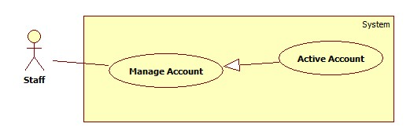

|  |  |  |  |
| --- | --- | --- | --- |
| **USE CASE – SU002** | | | |
| **Use Case No.** | SU002 | **Use Case Version** | 2.0 |
| **Use Case Name** | Active Account | | |
| **Author** | Tran Le Tuan | | |
| **Date** | 15/01/2014 | **Priority** | Normal |
| **Actor:** Staff  **Summary:**  Staff use this case to active user account  **Goal:**  Allow staff active an inactive account  **Triggers:**   * In our system, when we do not want an user to login, we inactive his/her account. We can active the inactivate account so they can login again. * To active an account, staff must: * From the Home Page, click the menu item “Quản lý tài khoản”. * Check the checkbox of the account record, select “Kích hoạt” on the drop down list, and press “Xác nhận” button.   **Preconditions:**   * Staff must login. * There must be at least 1 inactive account in database.   **Post Conditions:**   * **Success:** The selected account(s) will be activated. * **Fail:** No account activated.Transfer to error page.   **Main Success Scenario:**   |  |  |  | | --- | --- | --- | | Step | Actor Action | System Response | | 1 | Click menu item “Quản lý tài khoản”. | Redirect to Account Manager Page,  With table with 4 column:   * Số thứ tự: label * Tên người dùng: label * Email: label * Trạng thái: label * Action: dropdownlist, values: Khóa, Kích hoạt. * Process: button | | 2 | Check the dropdownlist of the account(s), select “Kích hoạt” on the drop down list, and press “Xác nhận” button. | The selected account(s) will be activated  [Exception 1,2] |   **Alternative Scenario:** N/A  **Exceptions:**   |  |  |  | | --- | --- | --- | | No | Actor Action | System Response | | 1 | The account has already been activated by another staff | Nothing happen, the account(s) status is active | | 2 | Check no checkbox, press “Xác nhận” button | Display error message:  “Chọn tài khoản kích hoạt.” |   **Relationships:** Manage Account  **Business Rules:**   * Staff can’t active account of themselves or other staff. | | | |

Deactive account

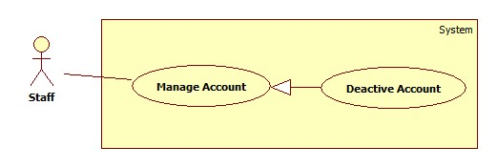

|  |  |  |  |
| --- | --- | --- | --- |
| **USE CASE – SU003** | | | |
| **Use Case No.** | SU003 | **Use Case Version** | 2.0 |
| **Use Case Name** | Deactive Account | | |
| **Author** | Tran Le Tuan | | |
| **Date** | 15/01/2014 | **Priority** | Normal |
| **Actor:** Staff  **Summary:**  Staff use this case to deactive user account  **Goal:**  Allow staff inactive an active account  **Triggers:**   * In our system, when we want’s an user to login. We can inactive the inactivate account so they can’t login again. * To active an account, staff must: * From the Home Page, click the menu item “Quản lý tài khoản”. * Check the checkbox of the account record, select “Khóa” on the drop down list, and press “Xác nhận” button.   **Preconditions:**   * Staff must login. * There must be at least 1 active account in database.   **Post Conditions:**   * **Success:** The selected account(s) will be inactivated. * **Fail:** No account inactivated.Transfer to error page.   **Main Success Scenario:**   |  |  |  | | --- | --- | --- | | Step | Actor Action | System Response | | 1 | Click menu item “Quản lý tài khoản”. | Redirect to Account Manager Page,  With table with 4 column:   * Số thứ tự: label * Tên người dùng: label * Email: label * Trạng thái: label * Action: dropdownlist, values: Khóa, Kích hoạt. * Process: button | | 2 | Check the dropdownlist of the account(s), select “Khóa” on the drop down list, and press “Xác nhận” button. | The selected account(s) will be inactivated  [Exception 1,2] |   **Alternative Scenario:** N/A  **Exceptions:**   |  |  |  | | --- | --- | --- | | No | Actor Action | System Response | | 1 | The account has already been inactivated by another staff | Nothing happen, the account(s) status is inactive | | 2 | Check no checkbox, press “Xác nhận” button | Display error message:  “Chọn tài khoản khóa.” |   **Relationships:** Manage Account  **Business Rules:**   * Staff can’t inactive account of themselves or other staff. | | | |

Delete report

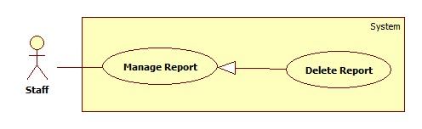

|  |  |  |  |
| --- | --- | --- | --- |
| **USE CASE – SU004** | | | |
| **Use Case No.** | SU004 | **Use Case Version** | 1.0 |
| **Use Case Name** | Delete Report | | |
| **Author** | Ho Dac Nghia | | |
| **Date** | 15/01/2014 | **Priority** | Normal |
| **Actor:** Staff  **Summary:**  Staff use this case to delete report.  **Goal:**  Allow staff to delete report.  **Triggers:**   * Click menu item "Quản lí phản hồi". * On the report list, click report item to view details of report. * Click "Xóa" to delete report. * Click “Đồng ý”.   **Preconditions:**   * Staff must log in the system. * There must be at least one report in the report list   **Post Conditions:**   * **Success:** The report of a traffic sign will be removed from server and database * **Fail:** No report removed   **Main Success Scenario:**   |  |  |  | | --- | --- | --- | | Step | Actor Action | System Response | | 1 | Click menu item “Quản lí phản hồi”. | Redirect to Report List Page, contains:  Table with 4 columns, record of 20 latest report:  - Mã số: label  - Tên người phản hồi: label  - Thời gian: label  - Nội dung: label  - Xem chi tiết: link | | 2 | Click on “xem chi tiết” link | Redirect to Report Detail Page, contains detail of User’s Report, include:  Mã số: label  -Tên người phản hồi: label  -Thời gian: label  -Nội dung: label  -Hình ảnh kết quả nhận diện: label  -Xóa: button | | 3 | Click on the “Xóa” button | Show confirms windows with message:  “Bạn có muốn xóa phản hồi này.” | | 4 | Click “Đồng ý” button.  [Alternative 1] | The selected report will be removed from server.  An message is display: “Phản hồi đã được xóa”. |   **Alternative Scenario:**   |  |  |  | | --- | --- | --- | | No | Actor Action | System Response | | 1 | [Alternative 1]  Click “Hủy” | System close message box. |   **Exceptions:** N/A **Relationships:** N/A  **Business Rules:** N/A | | | |